SIMATS Engineering – Internet Programming
Assessment Tool 1:
SIMATS ENGINEERING CO1
-ASSESSMENT TOOL 1 – APPLICATION-BASED QUESTIONS
Student Name : T.Achyuth Naidu
Register Number :192372257
Course Name : Internet Programming
Course Code : CSA4307

Question 1: Online Symposium Portal
Corrected HTML code:
<!DOCTYPE html>
<html lang="en">
<head>
<meta charset="UTF-8">
<meta name="viewport" content="width=device-width, initial-scale=1.0">
<title>Symposium Registration</title>
</head>
<body>
<header>
<h1>Online Symposium Portal</h1>
</header>
<main>
<section>
<h2>Student Registration</h2>
<form action="/register" method="POST">
<label for="name">Name:</label>
<input type="text" id="name" name="name" required>
<label for="email">Email:</label>
<input type="email" id="email" name="email" required>
<button type="submit">Submit</button>
</form>
</section>
</main>
</body>
</html>

Expected browser output
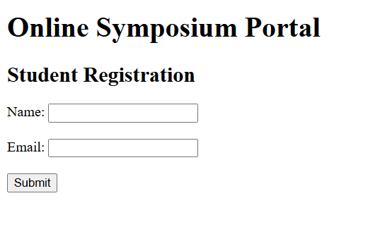

Question 2: Cross-Browser Compatibility
Corrected HTML code:
<!DOCTYPE html>
<html lang="en">
<head>
<meta charset="UTF-8">
<meta name="viewport" content="width=device-width, initial-scale=1.0">
<title>Company</title>
</head>
<body>
<header>
<h1>Welcome</h1>
</header>
<main>
<section>
<h2>About Us</h2>
<p>Welcome to our company website.</p>
</section>
</main>
<footer>
<p>Copyright 2026 Company</p>
</footer>
</body>
</html>

Expected browser output

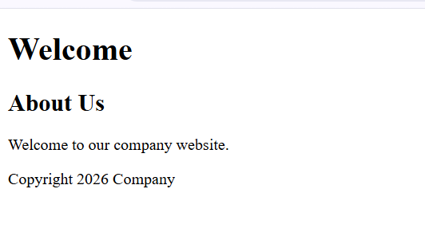

Question 3: Form Submission
Corrected HTML code:
<!DOCTYPE html>
<html lang="en">
<head>
<meta charset="UTF-8">
<meta name="viewport" content="width=device-width, initial-scale=1.0">
<title>Login Form</title>
</head>
<body>
<h1>Login</h1>
<form action="/submit" method="POST">
<label for="username">Username:</label>
<input type="text" id="username" name="username" required>
<label for="password">Password:</label>
<input type="password" id="password" name="password" required>
<button type="submit">Login</button>
</form>
</body>
</html>

Expected browser output

